**Experiment 1**

* **Aim:** Study of different types of Network cables and practically implement the cross-wired cable and straight through cable using clamping tool.
* **Apparatus (Components):** RJ-45 connector, Climping Tool, Twisted pair Cable
* **Procedure:**
* **Study of Different Types of Network Cables:** Network cables are the backbone of modern communication, allowing for the transmission of data between devices. They come in various types, each suited for specific applications and offering different performance characteristics. Understanding the differences between network cable types is essential for designing and maintaining efficient and reliable networks. Here, we will explore three common types of network cables: Coaxial cables, Twisted Pair cables, and Fiber Optic cables.

**1. Coaxial Cables:** This cable contains a conductor, insulator, braiding, and sheath. The sheath covers the braiding, the braiding covers the insulation, and the insulation covers the conductor.

The following image shows these components.

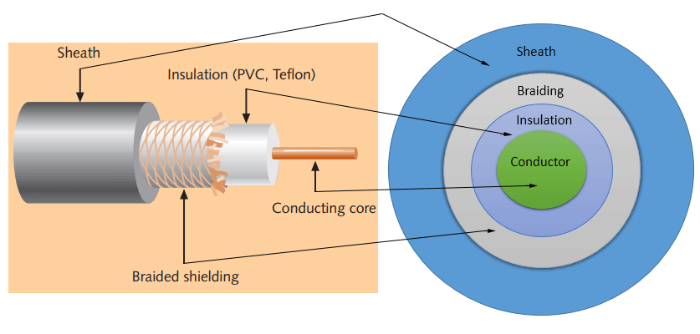

* **Sheath:** This is the outer layer of the coaxial cable. It protects the cable from physical damage.
* **Braided shield:** This shield protects signals from external interference and noise. This shield is built from the same metal that is used to build the core.
* I**nsulation:** Insulation protects the core. It also keeps the core separate from the braided shield. Since both the core and the braided shield use the same metal, without this layer, they will touch each other and create a short-circuit in the wire.
* **Conductor:** The conductor carries electromagnetic signals. Based on conductor a coaxial cable can be categorized into two types; single-core coaxial cable and multi-core coaxial cable.

A **single-core** coaxial cable uses a single central metal (usually copper) conductor, while a **multi-core** coaxial cable uses multiple thin strands of metal wires. The following image shows both types of cable.

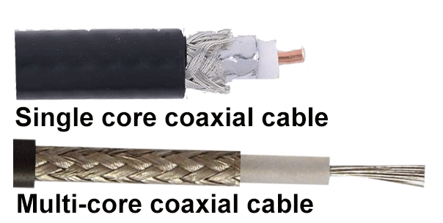

* **Coaxial cables in computer networks:** The coaxial cables were not primarily developed for the computer network. These cables were developed for general purposes. They were in use even before computer networks came into existence. They are still used even their use in computer networks has been completely discontinued.

At the beginning of computer networking, when there were no dedicated media cables available for computer networks, network administrators began using coaxial cables to build computer networks.

Because of its low cost and long durability, coaxial cables were used in computer networking for nearly two decades (the 80s and 90s). Coaxial cables are no longer used to build any type of

computer network.

* **Specifications of coaxial cables:** Coaxial cables have been in use for the last four decades. During these years, based on several factors such as the thickness of the sheath, the metal of the conductor, and the material used in insulation, hundreds of specifications have been created to specify the characteristics of coaxial cables.

From these specifications, only a few were used in computer networks. The following table lists them.

|  |  |  |  |  |
| --- | --- | --- | --- | --- |
| **Type** | **Ohms** | **AWG** | **Conductor** | **Description** |
| RG-6 | 75 | 18 | Solid copper | Used in cable network to provide cable Internet service and cable TV over long distances. |
| RG-8 | 50 | 10 | Solid copper | Used in the earliest computer networks. This cable was used as the backbone cable in the bus topology. In Ethernet standards, this cable is documented as the 10base5 Thicknet cable. |
| RG-58 | 50 | 24 | Several thin strands of copper | This cable is thinner, easier to handle and install than the RG-8 cable.  This cable was used to connect a system with the backbone cable.  In Ethernet standards, this cable is documented as the 10base2 Thinnet cable. |
| RG-59 | 75 | 20 - 22 | Solid copper | Used in cable networks to provide short-distance service. |

* + - * Coaxial cable uses RG rating to measure the materials used in shielding and conducting cores.
      * RG stands for the Radio Guide. Coaxial cable mainly uses radio frequencies in transmission.
      * Impedance is the resistance that controls the signals. It is expressed in the ohms.
      * AWG stands for American Wire Gauge. It is used to measure the size of the core. The larger the AWG size, the smaller the diameter of the core wire.

**2. Twisted-pair cables:** The twisted-pair cable was primarily developed for computer networks. This cable is also known as **Ethernet cable**. Almost all modern LAN computer networks use this cable.

This cable consists of color-coded pairs of insulated copper wires. Every two wires are twisted around each other to form pair. Usually, there are four pairs. Each pair has one solid color and one stripped color wire. Solid colors are blue, brown, green, and orange. In stripped color, the solid color is mixed with the white color.

Based on how pairs are stripped in the plastic sheath, there are two types of twisted-pair cable; UTP and STP.

In the **UTP (*Unshielded twisted-pair*) cable**, all pairs are wrapped in a single plastic sheath.

In the **STP (*Shielded twisted-pair*) cable**, each pair is wrapped with an additional metal shield, then all pairs are wrapped in a single outer plastic sheath.

* **Similarities and differences between STP and UTP cables**
  + - Both STP and UTP can transmit data at 10Mbps, 100Mbps, 1Gbps, and 10Gbps.
    - Since the STP cable contains more materials, it is more expensive than the UTP cable.
    - Both cables use the same RJ-45 (registered jack) modular connectors.
    - Both cables can accommodate a maximum of 1024 nodes in each segment.
    - The STP provides more noise and EMI resistance than the UTP cable.
    - The maximum segment length for both cables is 100 meters or 328 feet.

The following image shows both types of twisted-pair cables.

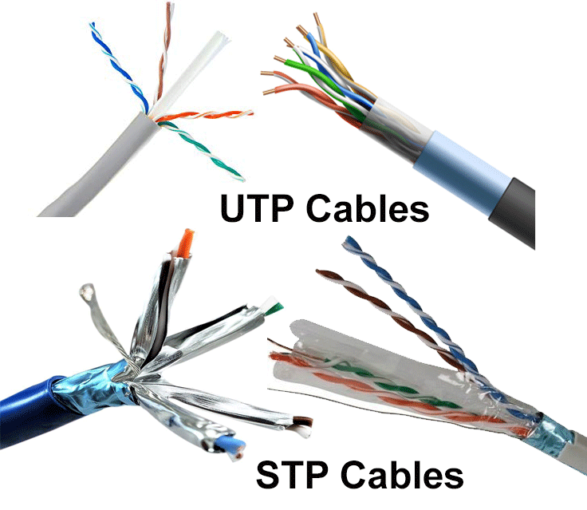

* + - Cat 1, 2, 3, 4, 5 are outdated and not used in any modern LAN network.
    - Cat 7 is still a new technology and not commonly used.
    - Cat 5e, 6, 6a are the commonly used twisted-pair cables.

**3. Fiber optic cable:** This cable consists of a core, cladding, buffer, and jacket. The core is made from thin strands of glass or plastic that can carry data over a long distance. The core is wrapped in the cladding; the cladding is wrapped in the buffer, and the buffer is wrapped in the jacket.

* + - Core carries the data signals in the form of light.
    - Cladding reflects light back to the core.
    - Buffer protects the light from leaking.
    - The jacket protects the cable from physical damage.

Fiber optic cable is completely immune to EMI and RFI. This cable can transmit data over a long distance at the highest speed. It can transmit data up to 40 kilometers at the speed of 100Gbps.

Fiber optic uses light to send data. It reflects light from one endpoint to another. Based on how many beams of light are transmitted at a given time, there are two types of fiber optical cable; SMF and MMF.

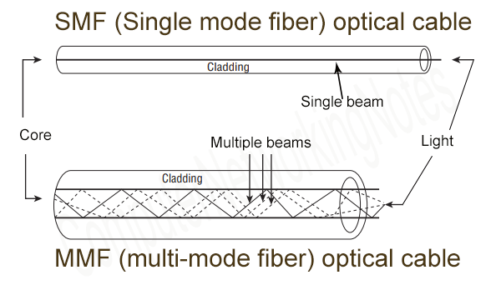

* + **SMF (Single-mode fiber) optical cable:** This cable carries only a single beam of light. This is more reliable and supports much higher bandwidth and longer distances than the MMF cable. This cable uses a laser as the light source and transmits 1300 or 1550 nano-meter wavelengths of light.
  + **MMF (multi-mode fiber) optical cable:** This cable carries multiple beams of light. Because of multiple beams, this cable carries much more data than the SMF cable. This cable is used for shorter distances. This cable uses an LED as the light source and transmits 850 or 1300 nano-meter wavelengths of light.
* **Implementation of Straight-Through Cable:** A straight-through cable is a type of twisted pair cable that is used in local area networks to connect a computer to a network hub such as a router. This type of cable is also sometimes called a patch cable and is an alternative to wireless connections where one or more computers access a router through a wireless signal. On a straight-through cable, the wired pins match. Straight-through cable use one wiring standard: both ends use T568A wiring standard or both ends use T568B wiring standard. The following figure shows a straight-through cable of which both ends are wired as the T568B standard.

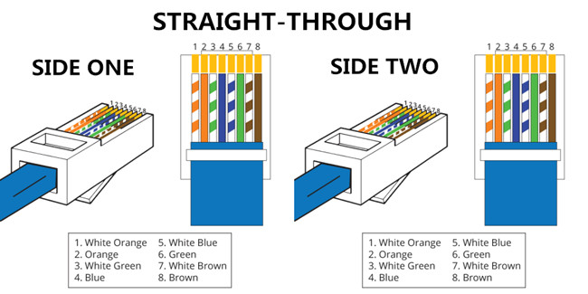

* **Implementation of Cross-Wired Cable:** An Ethernet crossover cable is a type of Ethernet cable used to connect computing devices together directly. Unlike straight-through cable, crossover cables use two different wiring standards: one end uses the T568A wiring standard, and the other end uses the T568B wiring standard. The internal wiring of Ethernet crossover cables reverses the transmit and receive signals. It is most often used to connect two devices of the same type: e.g. two computers (via network interface controller) or two switches to each other.

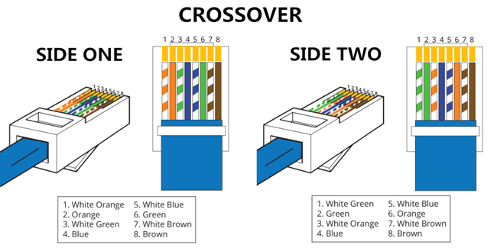

* **Difference of Straight Through and Crossover Cable:** Ethernet cables can be wired as straight through or crossover. The straight through is the most common type and is used to connect computers to hubs or switches. They are most likely what you will find when you go to your local computer store and buy a patch cable. Crossover Ethernet cable is more commonly used to connect a computer to a computer and may be a little harder to find since they aren’t used nearly as much as straight through Ethernet cable. Then, what’s the difference between straight through vs crossover cable? Read through this post to find the answer.
* **T568A And T568B Wiring Standard Basis:** A RJ45 connector is a modular 8 position, 8 pin connector used for terminating [Cat5e patch cable](https://www.fs.com/c/cat5e-patch-cables-593) or [Cat6 cable](https://www.fs.com/c/cat6-patch-cables-594). A pinout is a specific arrangement of wires that dictate how the connector is terminated. There are two standards recognized by ANSI, TIA and EIA for wiring Ethernet cables. The first is the T568A wiring standard and the second is T568B. T568B has surpassed 568A and is seen as the default wiring scheme for twisted pair structured cabling. If you are unsure of which to use, choose 568B.

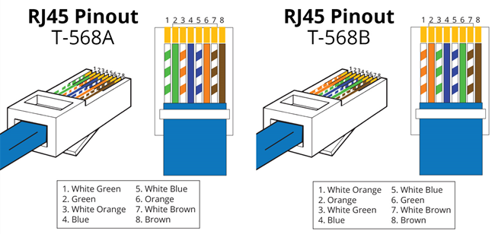

* **Straight Through vs Crossover Cable, which to choose:** Straight Through vs Crossover Cable, which to choose? Straight through vs crossover cable, which one should I choose? Usually, straight through cables are primarily used for connecting unlike devices. And crossover cables are use for connecting alike devices.

Use straight through Ethernet cable for the following cabling:

* Switch to router
* Switch to PC or server
* Hub to PC or server

Use crossover cables for the following cabling:

* Switch to switch
* Switch to hub
* Hub to hub
* Router to router
* Router Ethernet port to PC NIC
* PC to PC

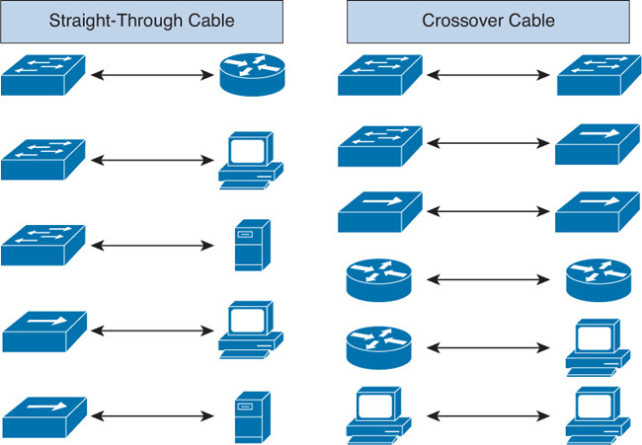

* **Network cable Crimping and Testing Tools:** This explains the most common twisted-pair network cable testing and crimping tools in detail. Learn the tools that we can use to crimp and test twisted-pair network cables.

Cables are the backbone of a wired network. The stability, reliability, and performance of a wired network depend on cables. Installing and maintaining cables in a wired network is a difficult task.

To make this task easier, a variety of network cable crimping and testing tools are available. we will discuss some of the most common network cable crimping and testing tools and also understand their features and functions.

* **Twisted-pair (STP and UTP) network cable crimping tools**

Crimping tools are used for the following purposes.

* To cut the network cable of the required length from the bundle.
* To remove the outer and inner jackets of the network cable.
* To attach the connectors on both ends of the cable.

Some crimping tools provide all the functionality while others provide one or two functionalities. The most common twisted-pair network cable crimping tools are described below.

**Wire Cutter**: - To cut the network cable of the required length from the bundle, you can use any standard wire cutter tool or can use a wire cutter tool that is specially designed for the twisted-pair cable. A twisted-pair wire cutter usually includes additional blades for stripping the wire.

**Wire Stripper**: - This tool is used to remove the outer and inner jackets of the network cable. Typically, you do not need to purchase this tool separately as all standard twisted-pair wire cutters are equipped with wire-strippers.

The following image shows two twisted-pair wire cutter tools equipped with wire-strippers.

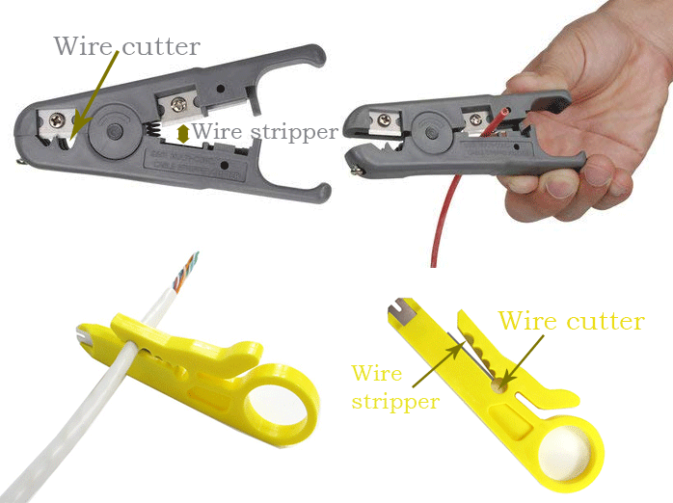

**Crimp tool**: - This tool is used to attach the connectors to the cable. Typically, this tool also includes a wire-cutter and wire-stripper. So, if you buy a crimp tool, you don't have to buy a wire-cutter and wire-stripper separately.

The following image shows a crimping device equipped with a wire-stripper and wire-cutter.

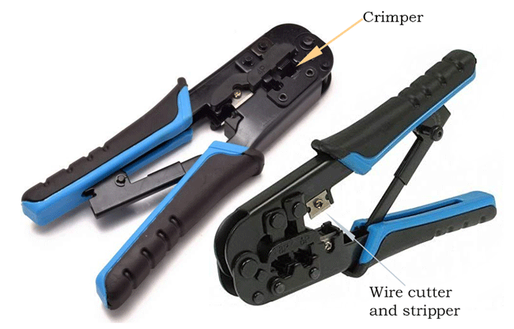

Which tool you should buy depends on your requirements and budget. For example, if you want to install a dozen network cables, you can buy less expensive tools such as a low-cost wire stripper and a cheap crimp device. But if you are in a network cable setting-up business or have a medium or large-sized network, you should buy a crimping tool that has a built-in wire stripper and wire cutter. A high-quality twisted-pair cable crimping tool will cost you around $100 but will save you many headaches in the long run.

* **Network cable testing and troubleshooting tools:** A network cable testing and troubleshooting tool is used for the following purposes.
* To measure the length of a segment or network cable.
* To detect loose connectors.
* To identify an un-labeled network cable from all network cables.
* To find a break in the network cable.
* To certify the cable installation.

The following section describes the most common network cable testing and troubleshooting tools.

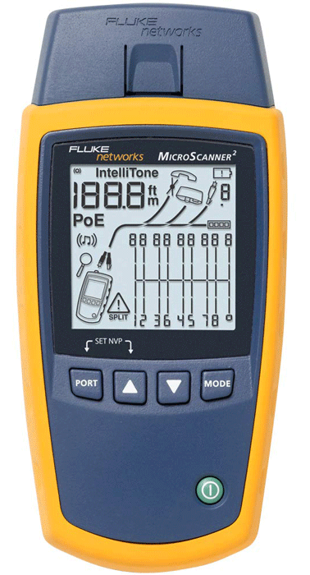

**Cable certifier: -** This device thoroughly tests a network cable and certifies that the cable installation meets a special wiring standard such as Cat 5e, Cat 6, Cat 6a, and so on. This device can check and test total segment length, crosstalk, noise, wiremap, resistance, impedance, and the capability to transfer data at the maximum frequency rated for the cable.

Since this device performs a complete test and certifies the cable installation, it will cost you more than all the other test devices listed in this section. If you have a mid-size network or if you can buy this device, then you should always buy and use this device to manage network cables.

**Basic cable tester: -** If you can't afford a network cable certifier, you can buy and use this device to manage your network cables. Besides certifying the cable installation, this device provides all remaining functionalities of a network cable certifier. It can test cable length, cross talk, and breaks in the cable. It can also check whether the connectors on both ends of a network cable are properly attached or not.

The following image shows a basic network cable tester tool.

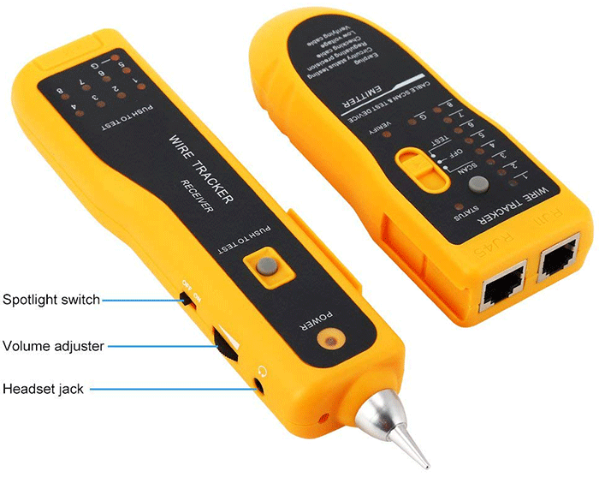**Tone generator and the probe: -** This device is used to trace the unlabeled network cables. This device comes in two pieces: the tone generator and the probe. The tone generator generates tones or signals and places them on the network cable. The probe detects these signals on the other end of the cable.

You can use this tool to identify network cables that run from a central location to remote locations. For example, if you are working on a patch-panel or a switch and trying to figure out which network cable connects back to an end-device (such as a PC), then you can use this device.

Place a tone generator at one end of the connection (end-device), and use the probe on another side (switch or patch-panel) to determine which network cable the tone generator is connected to.

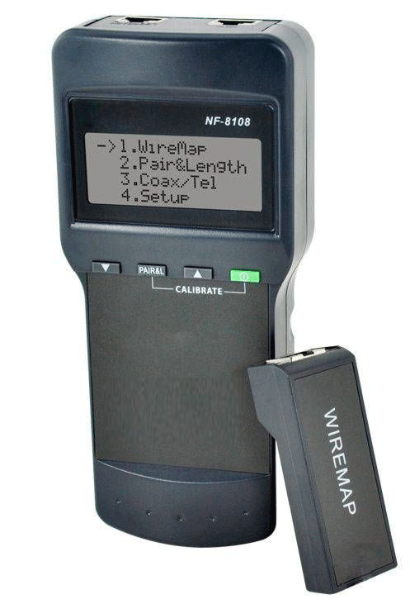

**Time domain reflectometer: -** This device is used to measure the length of a network cable as well as the breaks in the cable. This device transmits a signal on one end and measures the time that the signal takes to reach the end of the cable. You can also use this device to find breaks in the cable. For example, this device can tell you approximately how far the break is located in the cable.